**Alekhya Krishna Balivada Azure Databricks Assessment-2 (29-12-2023)**

**Cluster Creation from the existing Resourse**

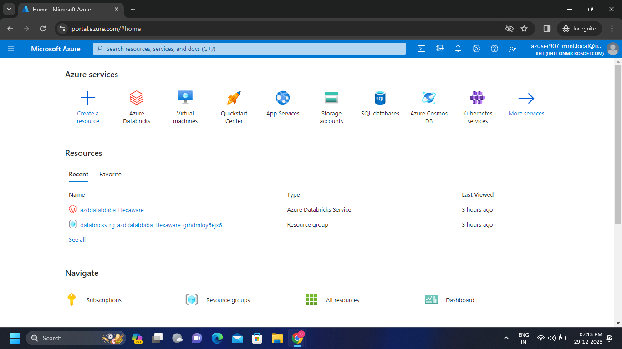**Step – 1:** Create a new cluster from the existing resource which is “azddatabiba_Hexaware”.

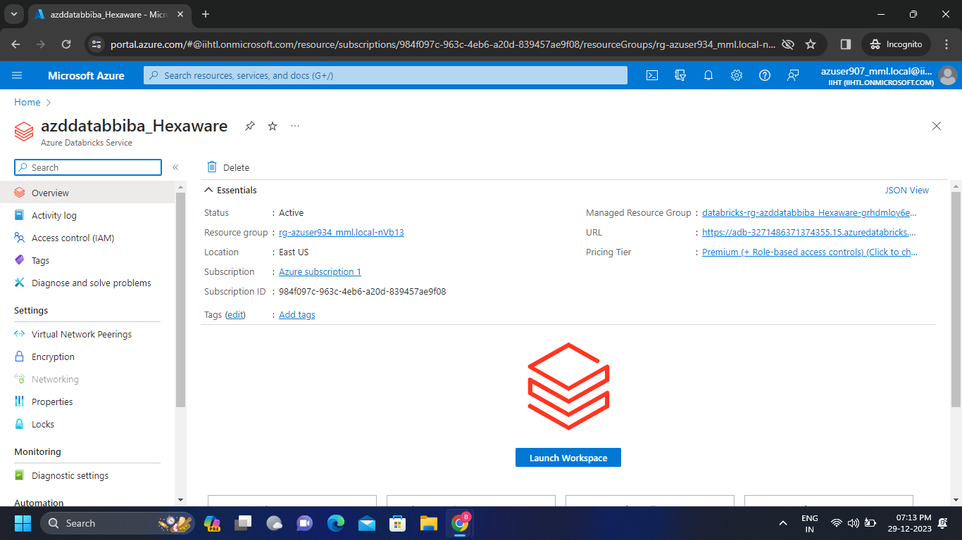**Step – 2:** After opening the resourse we get the following page and now launch the workspace.

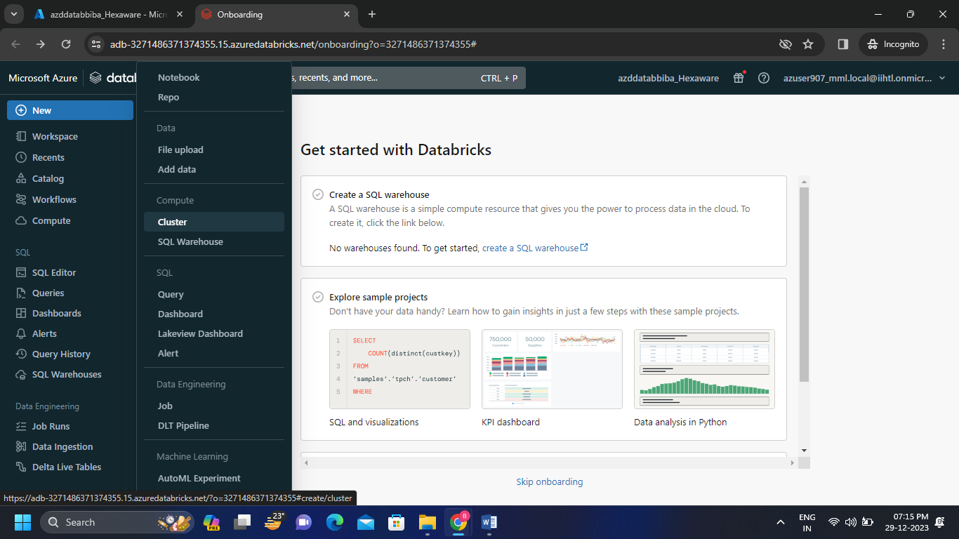**Step – 3:** Click on new then click on cluster to create new cluster in the existing resourse.

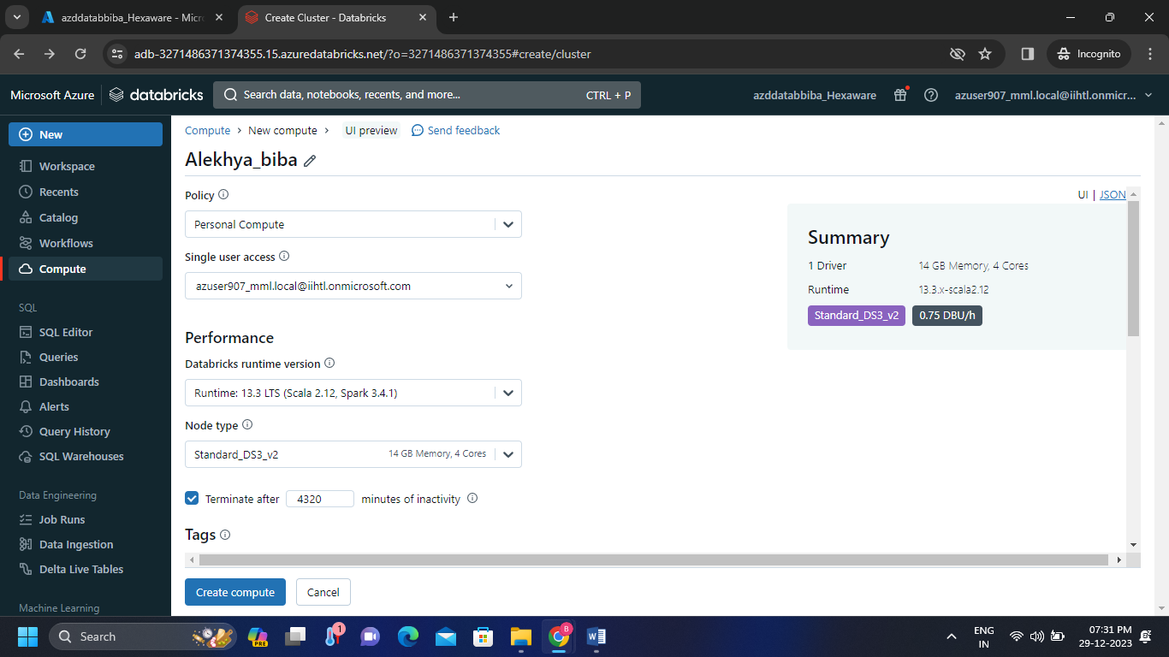**Step – 4:** Fill all the required details and create the cluster by clicking on “create compute”.

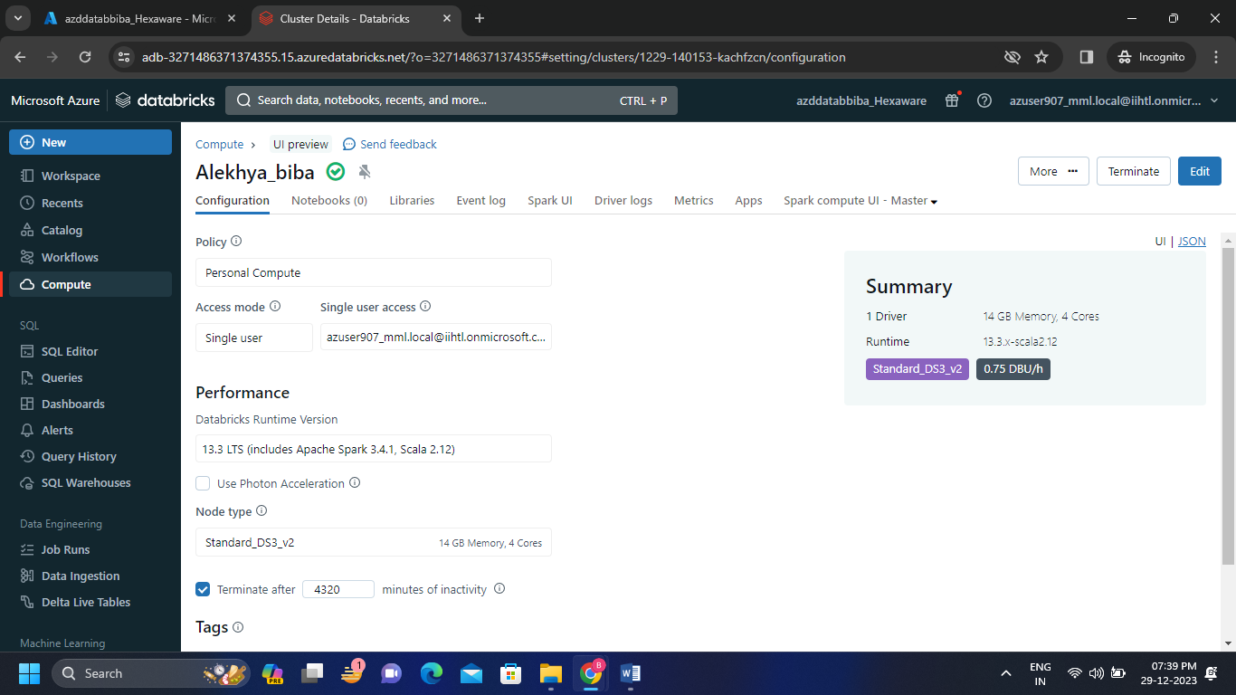**Step – 5:** The cluster is successfully created by getting the tick mark next to the cluster name.

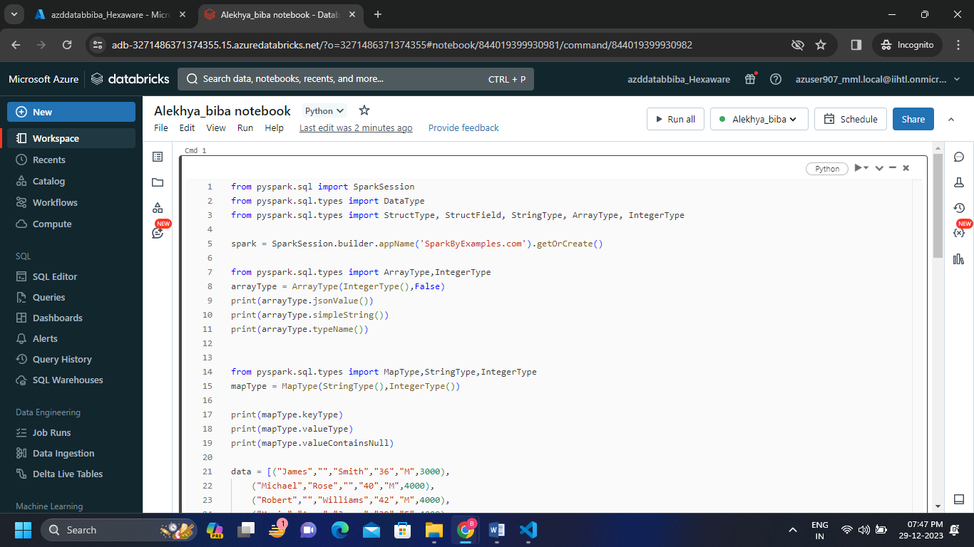**Step – 6:** I have created a notebook to run the codes which is by default connected to the created cluster.

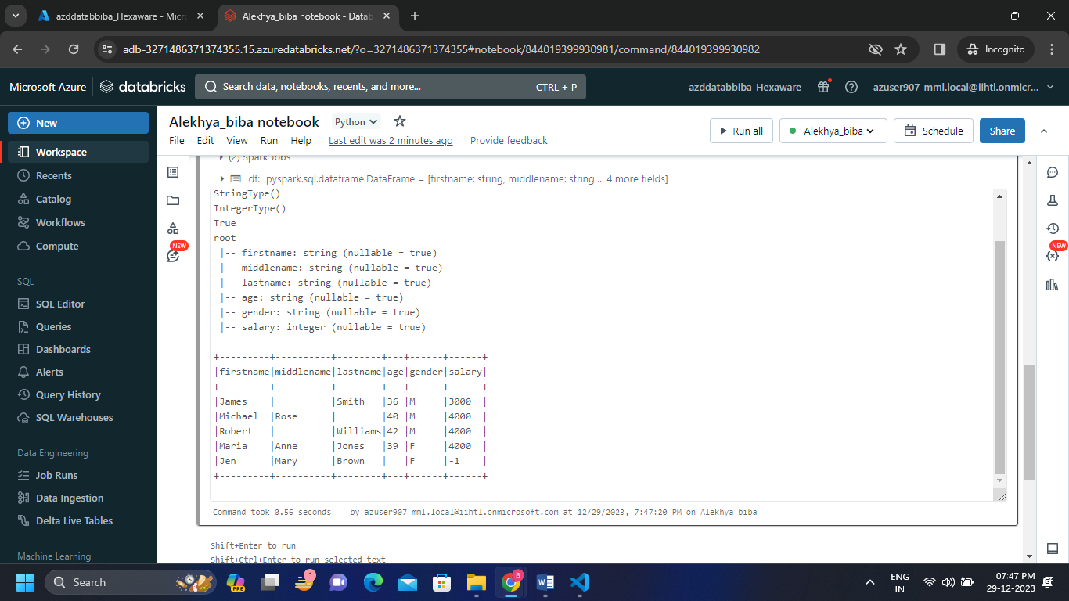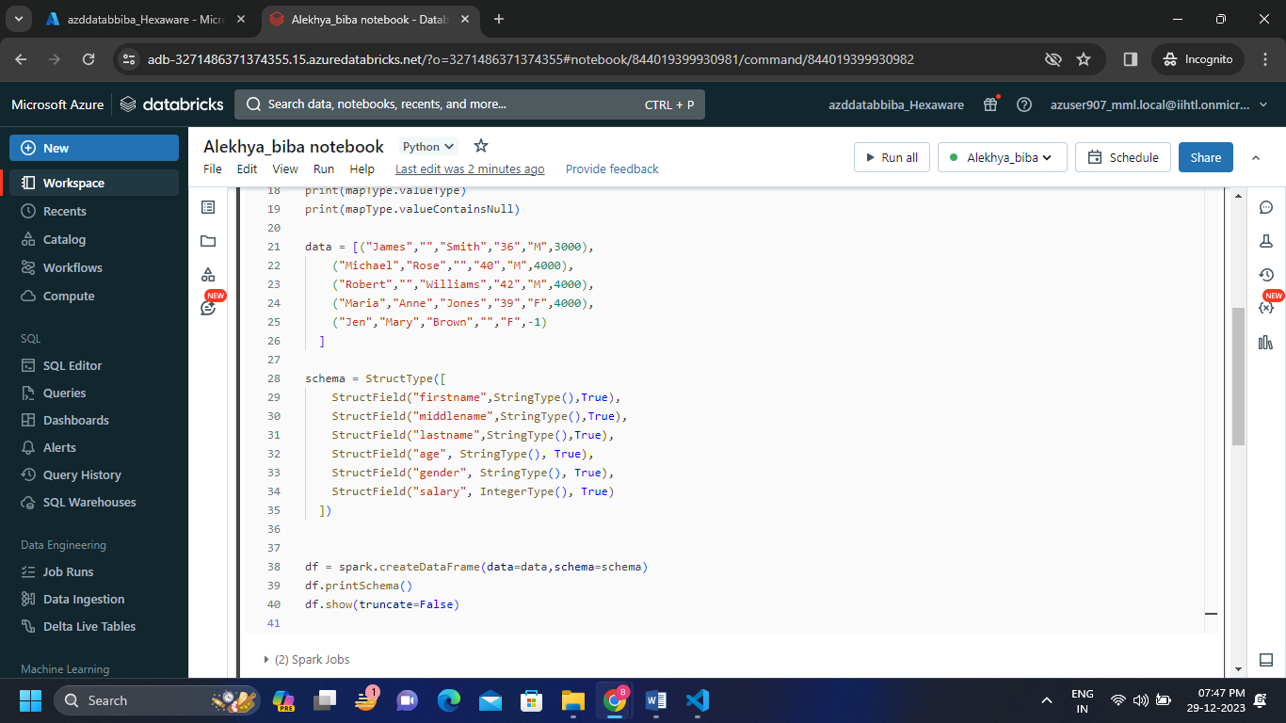

I have successfully executed a code on my notebook which is in my cluster.

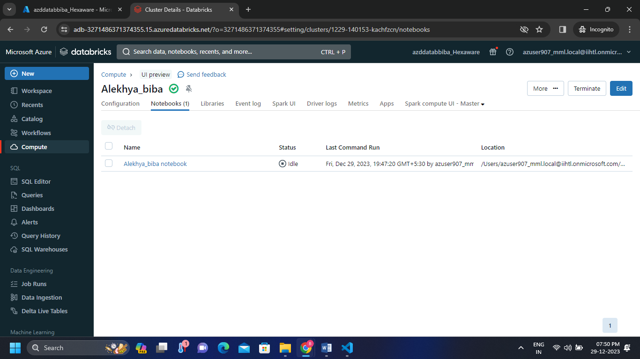**Step – 7:** I can see my notebook in compute cluster.

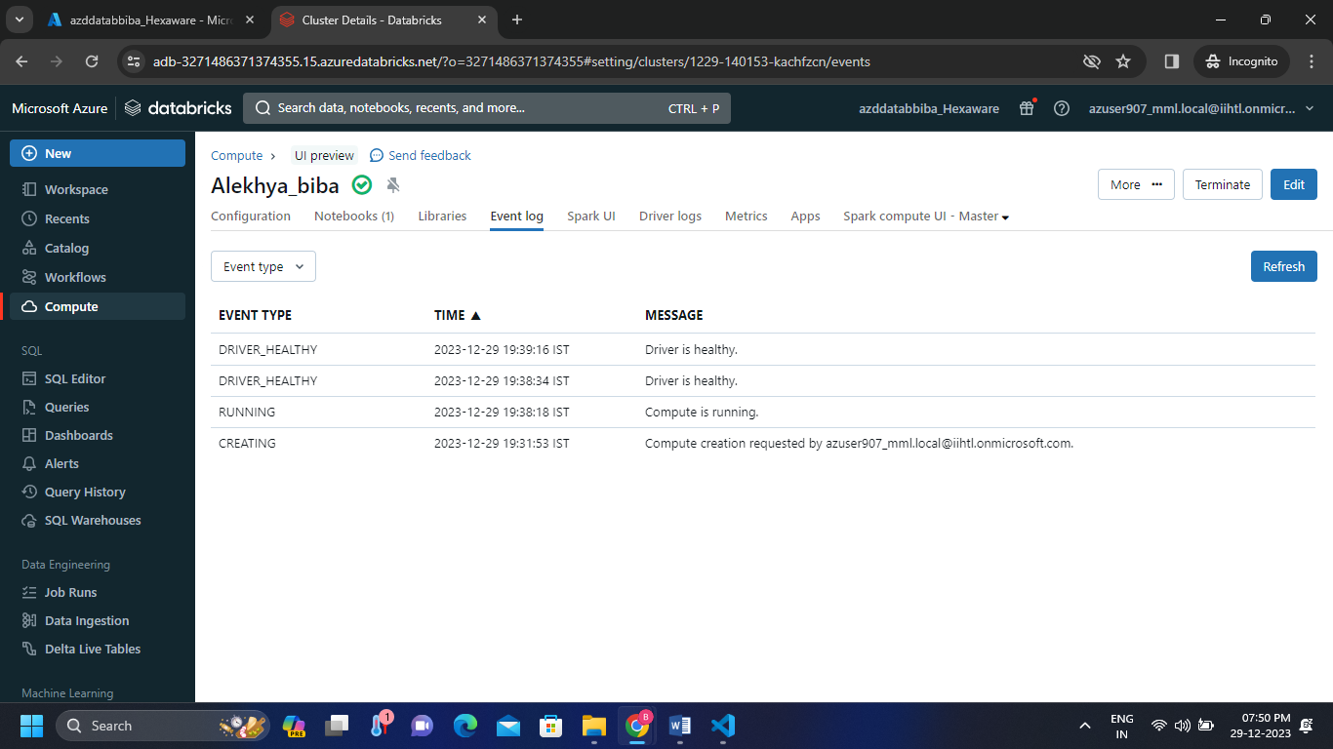**Step – 8:** I can see the event log and spark UI in my cluster.

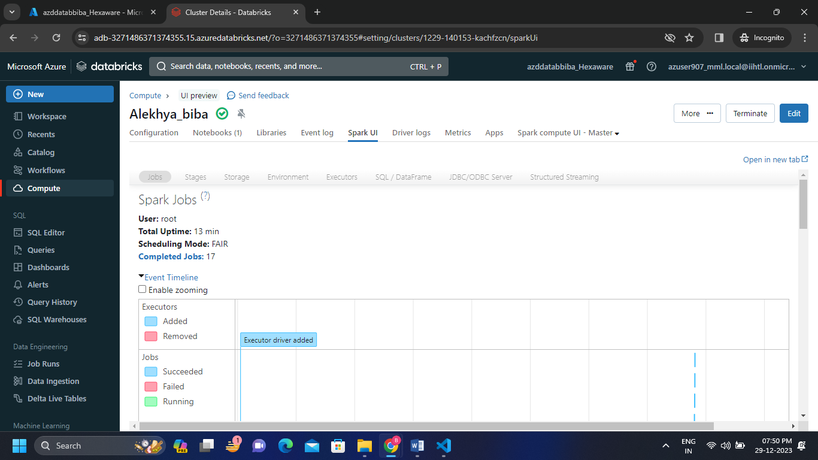

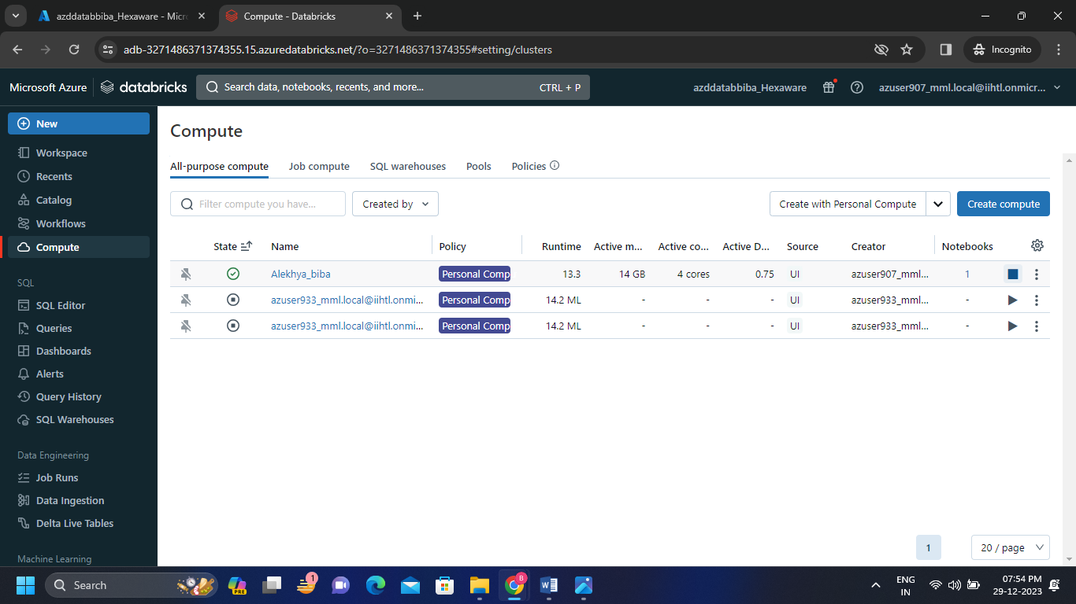**Step – 9:** After successfully executing the code I’m terminating the cluster by clicking on terminate.

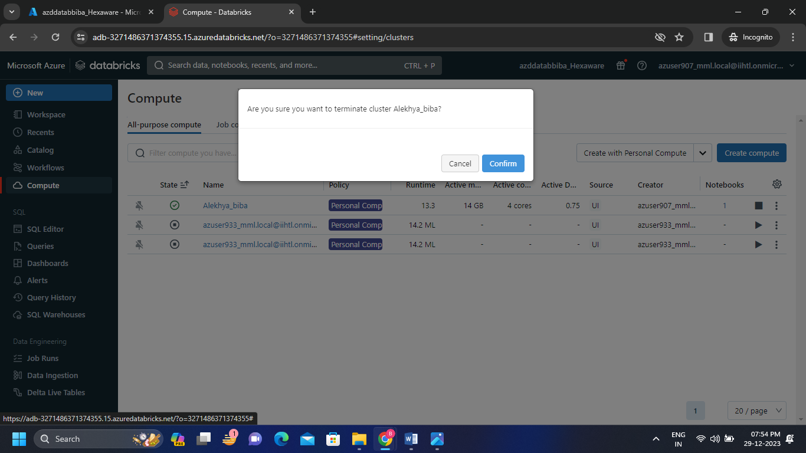

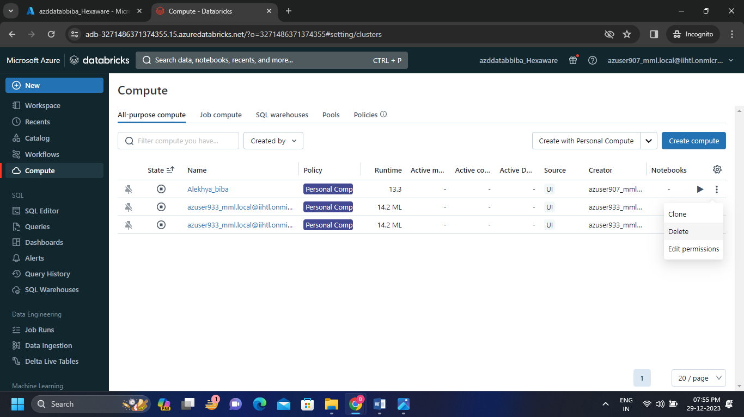**Step – 10:** After terminating the cluster I’m permanently deleting the cluster which we can’t undo it.

